Is there anything else we should know about?
eg.custody arrangements, special needs, behavioural issues?

Permissions:

Please tick this box if you are happy for your child to be included in photos used for media or promotional purposes. Images will only be used to celebrate or promote our programs.

Please tick this box if you are happy for your child to be taken on fully supervised visits to the Museum.

Please tick this box if you are happy for your email address to be added to our database.

Email address:________________________________________________

Name of Parent/Guardian: ______________________________________

Signed:_____________________________ Dated:___________________

Account Details for Online Banking:

02-0412-0143411-000 Rotorua Childrens Art House Trust

Please put your child’s surname and the type of class as the reference eg.
Smith Uke

Please contact Maria on ​0224306007 with any questions or concerns.

Rotorua Children’s Art House
The Gardener’s Cottage, Government Gardens, Rotorua
Contact: childrensarthouse@gmail.com
Office: 1240 Hinemaru St, Rotorua 3010

DB
MC
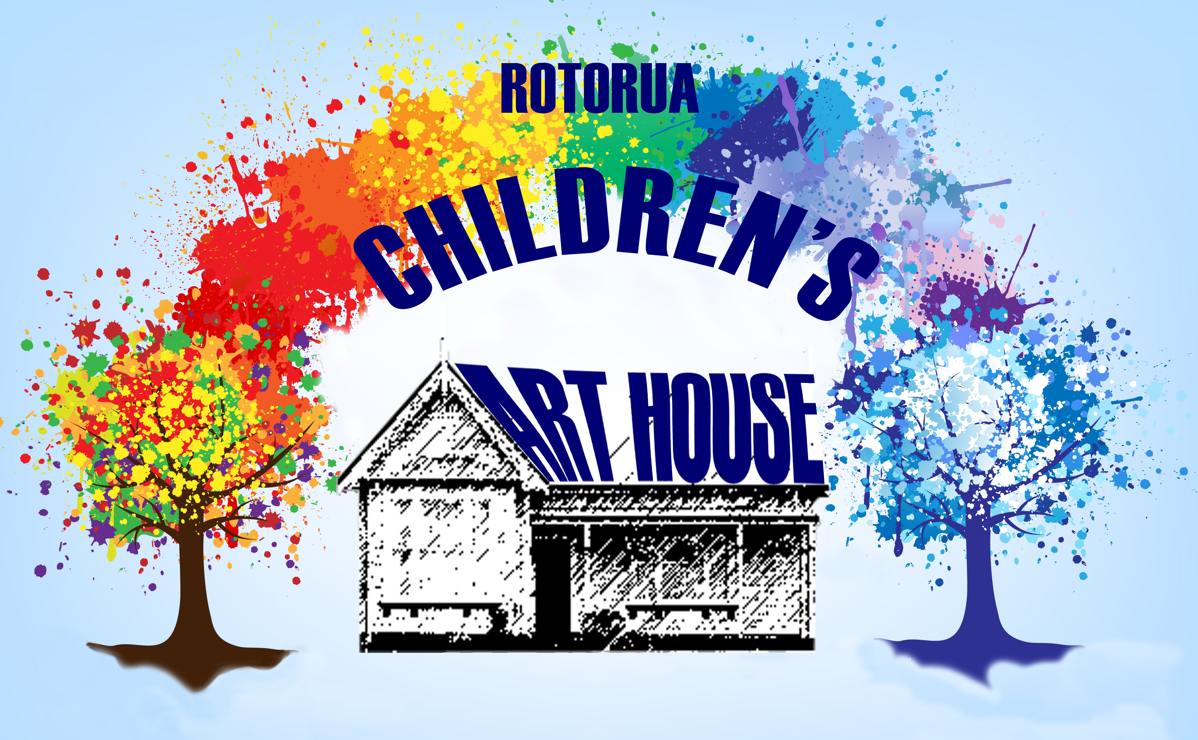
Registration Form
Child’s Name (1) :_______________________________________________ Age: _________ Boy / Girl

Date of Birth: ____________ Ethnicity: __________________________ Ngati Whakaue: Yes/No

Visual Arts  5-12 yrs | Visual Arts  5-12 yrs | Visual Arts 13+ | Ukulele | Ukulele-  Advanced | Ukulele
Mondays  3.30-5pm | Tuesdays  3.30- 5pm | Wednesdays  3.30-5pm | Mondays  3.30-4.30 | Mondays  3.30-4.30 | Friday  3.30-4.30

Child’s Name (2) :_______________________________________________ Age: _________ Boy / Girl

Date of Birth: ____________ Ethnicity: __________________________ Ngati Whakaue: Yes/No

Visual Arts  5-12 yrs | Visual Arts  5-12 yrs | Visual Arts 13+ | Ukulele | Ukulele-  Advanced | Ukulele
Mondays  3.30-5pm | Tuesdays  3.30- 5pm | Wednesdays  3.30-5pm | Mondays  3.30-4.30 | Mondays  3.30-4.30 | Friday  3.30-4.30
**All lessons are $50 for the Term, $5 per session

Primary/ Emergency Contact:
Name:____________________ Relationship to child: _________________________

Address: ________________________________________________________________________

Telephone Contact: ___________________________________

Contact 2: _________________________ Relationship to child: _________________________

Address: _______________________________________________________________________

Telephone contact:_________________________________

People authorised to collect your children:

Additional Information: Does your child have any particular health needs we should be aware of?
eg. Allergies, asthma, medical conditions;
______________________________________________________________________________________

Parent’s Name:

Contact Details:

Address:

Phone:

